**Machine Learning Software 1.0 vs Software 2.0 Report**

**Project 1.1**

**Software 1.0**

No of Correct Answer:100

No of Total Answers: 100

$$Accuracy=\frac{Number of Correct Answers}{Number of Total Ansers}= \frac{100}{100}=1$$

Error: 1 – Accuracy = 1 - 1 =0

Accuracy: 100.00%

Software 1.0 code has a 100% accuracy as it is based on logic-based approach like statements and conditions. We make use of if and else if statements to check if the number is divisible by 3 & 5. If it is divisible, we label it as Fizz Buzz.

Similarly, we check if number is divisible by 3 and in another condition divisible by 5 and label it as Fizz and Buzz respectively and none as the label for all the other inputs.

As we are using logic-based approach, the accuracy of Software 1.0 will always be 100% if appropriate inputs are fed into it.

**Software 2.0 (TensorFlow)**

No of Correct Answer:97

No of Total Answers: 100

Learning Rate=0.2 RELU Activation Function

$$Accuracy=\frac{Number of Correct Answers}{Number of Total Ansers}= \frac{97}{100}=0.97$$

Error: 1 – Accuracy = 1 – 0.97 =0.03 , Accuracy: 97.00%

Accuracy of Fizz=100% Fizz is predicted correctly all 27 times

Accuracy of Buzz=100% Buzz is predicted correctly all 14 times

Accuracy of Fizz Buzz=100% Fizz Buzz is predicted correctly all 6 times

Accuracy of Other=94.33% Other is predicted correctly only 50 out of 53 times

In the machine learning program, we create a program and feed the training data to the program so that the program can learn from the data and make accurate predictions in the future. We generally use 80 % to 90 % of the data as the training data or training set and the rest as the testing data for making actual predictions. The purpose of the machine learning program is to fit the dataset in such a way that a predictive model can be generated. The error function and the activation function also play a key role in the accuracy of the machine learning model. As a result, it is observed that even for a simple problem like Fizz Buzz, we are not able to achieve 100 % accuracy.

**Using TensorFlow and RELU Activation Function**

|  |  |  |  |  |  |  |  |  |  |  |
| --- | --- | --- | --- | --- | --- | --- | --- | --- | --- | --- |
| LEARNING RATE | 0.1 | 0.2 | 0.3 | 0.4 | 0.5 | 0.6 | 0.7 | 0.8 | 0.9 | 1 |
| ACCURACY  (%) | 97 | 98 | 97 | 87 | 93 | 87 | 94 | 98 | 91 | 78 |

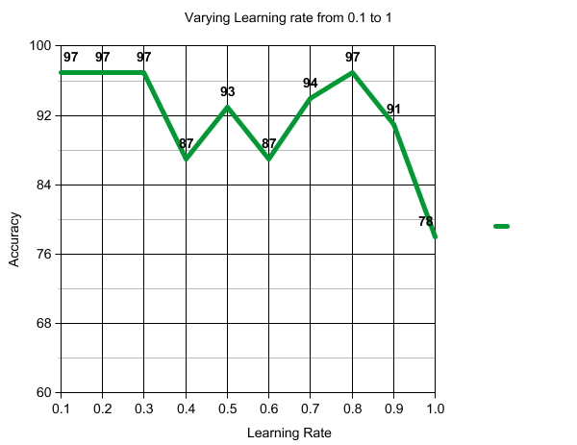

**Using TensorFlow and SIGMOID Activation Function**

|  |  |  |  |  |  |  |  |  |  |  |
| --- | --- | --- | --- | --- | --- | --- | --- | --- | --- | --- |
| LEARNING RATE | 0.1 | 0.2 | 0.3 | 0.4 | 0.5 | 0.6 | 0.7 | 0.8 | 0.9 | 1 |
| ACCURACY  (%) | 53 | 47 | 49 | 62 | 71 | 79 | 87 | 69 | 66 | 80 |

**Using Keras and RELU and 0.2 learning rate we have Accuracy=84%**

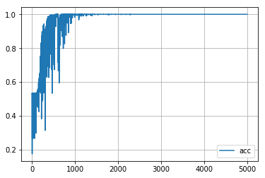

Accuracy=97% RELU TensorFlow Implementation

**Keras vs TensorFlow**

I tried both implementations i.e. using Keras and TensorFlow. Using Keras and the RELU activation function, I got an accuracy of 84%. TensorFlow provided accuracy of 97% using the RELU activation function. So TensorFlow is the better choice in terms of libraries.

**SIGMOID vs RELU**

While using TensorFlow, I tried to change the learning rate and the activation function. Using the SIGMOID activation function in TensorFlow the accuracy varied from 47 % to 87 % for various values of learning rate from 0.1 to 1.

With the RELU activation function, the accuracy of the Fizz Buzz program varied from 87 % to 97 % for various values of learning rate from 0.1 to 1 with the best accuracy being observed with learning rate of 0.2. TensorFlow provides better accuracy for this type of problem and RELU activation function with learning rate=0.2 provides the most accurate implementation of Fizz Buzz.

**Why Software 2.0?**

Machine Learning models can be used to solve multi variate regression problems as well as classification and other types of problems. They provide very good accuracy even though the size and number of features of dataset is large. They also help us overcome problems that cannot be easily solved by logic-based approach. In conclusion machine learning is bound to rise in the near future.